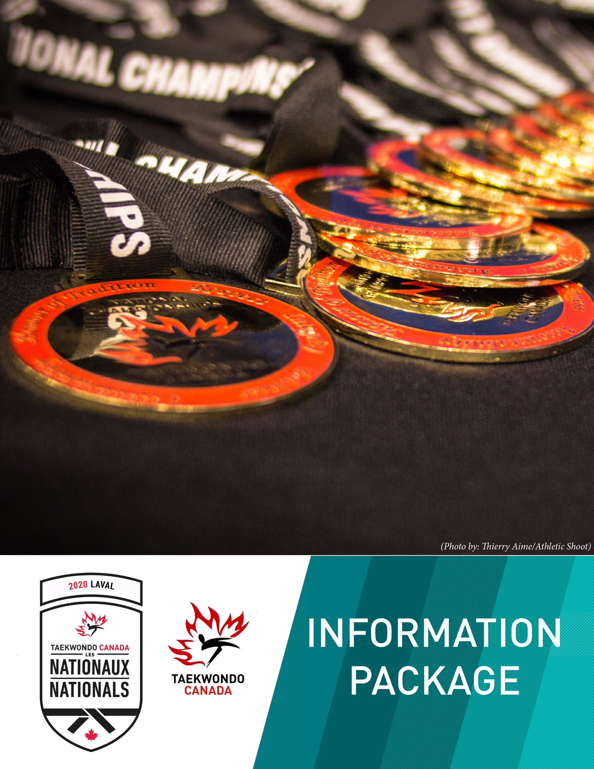

Table of Contents
1. ORGANIZATION ………………………………………………………………………………………… 4
2. VENUE AND DATE ………………………………………………………………………………..…… 4
3. ADMISSION ……………………………………………………………………………………………… 4
4. HOSPITALITY …………………………………………………………………………………………… 5
5. SCHEDULE ……………………………………………………………………………………………….. 5
6. REGISTRATION ………………………………………………………………………………………… 7
7. DRAWS ……………………………………………………………………………………………………. 8
8. LIABILITY AND WAIVER ……………………………………………………………………………. 8
9. ELIGIBILITY …………………………………………………………………………………………….. 9
10. POOMSAE COMPETITION ………………………………………………………………………… 10
11. SPARRING COMPETITIONS ………………………………………………………………………. 10
12. ANTI-DOPING …………………………………………………………………………………………. 12
APPENDIX 1 – PARTICIPANT AGREEMENT/WAIVER …………………………………………….. 13

ORGANIZATION

EVENT ORGANIZER

Taekwondo Canada
2451 Riverside Drive, Ottawa
ON, K1H 7X7
E: info@taekwondo-canada.com
T: (613) 695-5425

CONTACT US

Event: events@taekwondo-canada.com
GMS coordinator: gms@taekwondo-canada.com

VENUE AND DATE

VENUE

Sheraton Laval
2440 Laurentian Autoroute
Laval, QC, H7T 1X5

COMPETITION DATE

January 18-19, 2019

ADMISSION

Category | Adult | Kids 12 years old & under
1 Day Pass | $20 | $5

HOSPITALITY

Sheraton Laval
2440 Laurentian Autoroute
Laval, QC, H7T 1X5
Single Room, Double room: $155/ night + Tax

SCHEDULE

Poomsae Divisions:

Saturday, Jan 18/20 Sunday, Jan 19/20
Youth Individual Male/Female | Cadet Pairs
Cadet Individual Male/Female | Junior Pairs
O30 Pairs | Cadet Team
O30 Teams | Junior Team
Junior Individual Male/Female | 065/U65/U60/U50/U40/U30 Individual Male/Female
U30 Pairs/Teams | Youth Pairs
O30 Pairs/Teams | Youth Teams
Freestyle: O17 Pairs | Freestyle: U17 Pairs
Freestyle: O17 Teams | Freestyle: U17 Teams
Freestyle: U17 Male Individual | Freestyle: O17 Male Individual
Freestyle: U17 Female Individual | Freestyle: O17 Female Individual

Sparring Divisions: TBD- Final announcement Jan 7, 2020

January 17 (All events will happen at the Sheraton Laval
ID Pick Up: 12:00-3:00pm Room: TBA
Test Scales: 11:00am-1:45pm Room: TBA
Weigh in: 2:00pm-4:00pm Room: TBA
(Weigh in will only be for Day 1 athletes: Divisions TBD but expected to be Women’s Division 1 and Men’s Division 4)

Referee Meeting: 5:00pm Room: TBA
Technical Meeting: 7:00pm Room: TBA
January 18 (All events will happen at the Sheraton Laval)

Doors Open: 7:30am Sheraton Laval Ballroom
(Only accredited coaches and athletes will be allowed in before 8:00am)
Admission: 8:00am Sheraton Laval Ballroom
Random Weigh In: 7:30am Sheraton Laval Ballroom
ID Pick up: 9:00am-3:00pm Sheraton Laval (with admission)

Test Scales: 10am-1:30pm Room: TBA
Weigh in: 2:00pm-4:00pm Room: TBA
(Weigh in will only be for Day 2 athletes: Divisions TBD but expected to be Women’s Division 2 and Men’s Division 2)

Competition: 9:00am Sheraton Laval Ballroom
Sparring: Divisions TBD, Para K44.
Poomsae: see table above

January 19 (All events will happen at the Sheraton Laval)

Doors Open: 7:30am Sheraton Laval Ballroom
(Only accredited coaches and athletes will be allowed in before 8:00am)
Random Weigh In: 7:30am Sheraton Laval Ballroom
Admission: 8:00am Sheraton Laval Ballroom

Competition: 9:00am Sheraton Laval Ballroom
Sparring: Divisions TBD.
Poomsae: see table above
(subject to change)

REGISTRATION
PLEASE NOTE THAT AS WE ARE USING SIMPLYCOMPETE FOR REGISTRATION, PAYMENT IS IN USD.
https://taekwondocanada.simplycompete.com/events

Category | Regular Rate (USD)  (-Dec 30 , 11:59 EST) | Late Registration Rate (USD)  (Dec 31 – Jan 8, 11:59 EST)
Athlete/Team/Pair-1 event(sparring,individual poomsae, teams, pairs etc.) | $150.00 | $200.00
C1 Coach Fee (Comp Dev certified) | $0.00 | $50.00
C2 Coach Fee (DC certified) | $100.00 | $150.00
C3 Coach Fee (AI certified-can only do this one time) | $200.00 | $250.00
Trainer – no access to field of play  Team manager – no access  Team doctor – valid credentials are needed | $75.00 | $125.00
Category | Date | Price
Accreditation reprint (on site) | Jan 18-19, 2019 | $150.00
Taping  (purchase at the admission desk) | Jan 18-19, 2019 | $10.00
(not refundable)
NOTE: SHOULD AN ATHLETE REGISTER FOR AN OLYMPIC WEIGHT DIVISION THAT IS NOT GOING TO BE COMPETED (AS PER THE JANAURY 2020 RANKINGS), A REFUND WILL BE PROVIDED, OR THE ATHLETE MAY CHOOSE TO SELECT ANOTHER WEIGHT CLASS THAT IS SELECTED FOR COMPETITION.

DRAWS
POOMSAE- POOMSAE DRAWS WILL BE POSTED IMMEDIATELY FOLLOWING THE TECHNICAL MEETING, WHERE THEY WILL BE DRAWN.
SPARRING- SPARRING DRAWS WILL BE FULLY SEEDED USING JANUARY 2020 OLYMPIC RANKINGS. DRAWS WILL BE POSTED FOLLOWING THE TECHNICAL MEETING AND WEIGH INS

LIABILITY AND WAIVER

As a requirement for event registration, participants must agree to the terms and conditions listed in the appendix 1.

ELIGIBILITY

ELIGIBILITY: ATHLETES

- Must be a Canadian citizen
- Must be in good standing with their P/TSOs and Taekwondo Canada
- Must have a VALID 2020 Global Athlete License with event pass
- It is athletes’ responsibility to have secondary coach when the primary coach is not available during the event. The matches/poomsae divisions will not be held for coaches.

ELIGIBILITY: COACH

- Must be in good standing with their P/TSO and Taekwondo Canada
- Must have a VALID 2020 Global License with event pass
- As a minimum, coaches must have engaged in Taekwondo NCCP training at the Beginner Instructor level (Assistant-Instructor).
  - C1 - Performance Coach certified
  - C2 - Dojang Coach certified
  - C3 - AI certified (may only register as this once in a lifetime)
- Must be registered and in good standing with the Coaching Association of Canada's Professional Coaching department

ELIGIBILITY: Trainer/Manager/Doctor

- Must be in good standing with their P/TSO and Taekwondo Canada
- Must have VALID 2020 Global License
- Trainers must be certified Taekwondo Canada NCCP C3
- Doctors must have appropriate medical certification

DRESS CODE: COACHES AND ATHLETES

- Coaches:
  - Athletic attire/team tracksuit or business attire
  - Closed footwear only; No heels or sandals
  - No chewing gum or use of electronic devices such as cell phone, PDA or video cameras
  - Any coach perceived to be under the influence of alcohol or drugs will not be allowed in the competition area

ELIGIBILITY: 2019 QUALIFICATION EVENTS

It is the responsibility of the coach and athlete to have read the team selection and event procedure information on Taekwondo Canada’s website.

POOMSAE COMPETITION

SCORING SYSTEM: KPNP

**Divisions will be competed as per the 2020 Poomsae World Championships selection document and youth poomsae**

SPARRING COMPETITION

IVR SYSTEM

IVR will be used for sparring divisions only.

PSS SYSTEM: Daedo Gen 2

WEIGH IN

- Weigh in for sparring competitors will take place one day prior to their competition day.
- Athletes will weigh-in during the time allotted on the day prior to their competition day.
- Athletes will have two attempts to make the weight within this time frame.
- There will be NO EXEMPTIONS to weigh in time

RANDOM WEIGH IN-SPARRING

Random weigh in lists will be posted prior to midnight on the night before each day of competition.

INSPECTION

Athletes will have 10 minutes to report to inspection with all requirement equipment on after they are called. Athletes receiving medical attention are not considered checked into inspection. Athletes who do not report to inspection with all required equipment on within the 10 minutes will be immediately disqualified. No exceptions.

EQUIPMENT

- WT recognized equipment must be worn. The equipment includes: Daedo Gen 2 socks, shin guards, groin protector, forearm guards, gloves, mouth guards (clear or white – medical will not approve colour mouth guards), sparring uniform or poomsae uniform as required. See the list of the World Taekwondo Recognized Brands here.

ANTI-DOPING

The WT Anti-Doping rules, and where necessary the Code of the World Anti-Doping Agency, shall apply throughout the competitions.

APPENDIX 1 – PARTICIPANT AGREEMENT/ WAIVER

Thank you for your interest in the 2020 Canadian National Taekwondo Championships. As a requirement for event registration, I agree to the following terms and conditions:
I declare that I am over the age of 18 years old or I am a parent/guardian of a participant under the age of 18 years old.
- I understand that as a condition of event participation, I must have insurance coverage in the event that I require emergency medical treatment. I may be asked to provide proof of my insurance information to the event organizers as a condition of participation.
- I am fully aware of the risks involved and the degree of fitness required in taking part in this event. I accept that the event organizers and their agents cannot be held responsible for any injury or loss, however caused.
- I have not suffered a concussion for which I have not been medically cleared to compete, or suffered a concussion for which I have not been treated in the last 30 days.
- I agree to allow Taekwondo Canada and their agents to capture myself on still image or video for the purposes of promotion.
- I understand that all fees are NON-REFUNDABLE.
- I understand that if I participate in a sparring division, I must be present at the weigh-in on the day prior to my competition and random weigh-in on the day of the competition as stated in the official schedule. I understand that there will not be any exceptions to this rule.
- I understand that all athletes and their clubs are required to register with Taekwondo Canada prior to registration.
- I understand that in order to pick up my accreditation or my child(ren)’s accreditation, I must present a valid photo identification for myself or for my child(ren).
- Athletes and coaches must adhere to the policies of the World Anti-Doping Agency (WADA). I understand that as a participant, I, or my athlete, may be subject to anti-doping testing.
- I have reviewed the list of prohibited substances recognized by WADA found on the Prohibited List.
- I understand that an athlete is required to declare a Therapeutic Use Exemption (TUE) for medication used for illness or other medical reasons if the medication is on WADA’s 2019 Prohibited Substance List. More information on TUE can be found here: http://cces.ca/medical-exemptions

PARTNERS

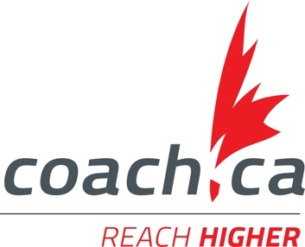
SPONSORS

